# 20180212

[root@m1-2-gp-prd-sdw1 ~]# yum install dell-system-update
Loaded plugins: etckeeper, product-id, search-disabled-repos, security, subscription-manager
This system is not registered with an entitlement server. You can use subscription-manager to register.
Setting up Install Process
Resolving Dependencies
--> Running transaction check
---> Package dell-system-update.x86_64 0:1.5.2-18.01.00 will be installed
--> Finished Dependency Resolution

Dependencies Resolved

=======================================================================================================
Package Arch Version Repository Size
=======================================================================================================
Installing:
dell-system-update x86_64 1.5.2-18.01.00 tcs-dell-dsu-os_independent 9.8 M

Transaction Summary
=======================================================================================================
Install 1 Package(s)

Total download size: 9.8 M
Installed size: 32 M
Is this ok [y/N]: y
Downloading Packages:
dell-system-update-1.5.2-18.01.00.x86_64.rpm | 9.8 MB 00:00
Running rpm_check_debug
Running Transaction Test
Transaction Test Succeeded
Running Transaction
etckeeper: pre transaction commit
Installing : dell-system-update-1.5.2-18.01.00.x86_64 1/1
etckeeper: post transaction commit
Verifying : dell-system-update-1.5.2-18.01.00.x86_64 1/1

Installed:
dell-system-update.x86_64 0:1.5.2-18.01.00

Complete!
[root@m1-2-gp-prd-sdw1 ~]#

[root@m1-2-gp-prd-sdw1 ~]# dsu --inventory
DELL EMC System Update 1.5.2
Copyright (C) 2014 DELL EMC Proprietary.
Verifying catalog installation ...
Installing catalog from repository ...
Fetching dsucatalog …
Reading the catalog ...
Fetching invcol_NJ94T_LN64_17_12_200_139_A00 ...
Verifying inventory collector installation ...
Getting System Inventory ...

1. OpenManage Server Administrator ( Version : 8.5.0 )

2. BIOS ( Version : 2.4.3 )

3. Lifecycle Controller ( Version : 2.41.40.40 )

4. Dell 32 Bit uEFI Diagnostics, version 4239, 4239A36, 4239.44 ( Version : 4239A36 )

5. OS COLLECTOR 2.1, A00 ( Version : 2.1 )

6. System CPLD ( Version : 1.0.1 )

7. Power Supply ( Version : 00.16.4F )

8. Power Supply ( Version : 00.16.4F )

9. NVMePCISSD Model Number: INTEL SSDPEDMD020T4D HHHL NVMe 2000GB ( Version : 8DV1DP05 )

10. Firmware for - Disk 0 in Backplane 1 of PERC H730P Mini Controller 0 ( Version : DM06 )

11. Firmware for - Disk 12 in Backplane 1 of PERC H730P Adapter Controller 1 ( Version : AM04 )

12. PERC H730P Mini Controller 0 Firmware ( Version : 25.5.2.0001 )

13. 13G Backplane Expander FW ( Version : 3.32 )

14. PERC H730P Adapter Controller 1 Firmware ( Version : 25.5.2.0001 )

15. iDRAC ( Version : 2.41.40.40 )

16. BCM57800 10-Gigabit Ethernet rev 10 (em1) ( Version : 08.07.26 )

17. BCM57800 10-Gigabit Ethernet rev 10 (em2) ( Version : 08.07.26 )

18. BCM57800 1-Gigabit Ethernet rev 10 (em3) ( Version : 08.07.26 )

19. BCM57800 1-Gigabit Ethernet rev 10 (em4) ( Version : 08.07.26 )

20. Inventory Collector ( Version : 2372.10488.el6 )

Exiting DSU!
[root@m1-2-gp-prd-sdw1 ~]#

[root@m1-2-gp-prd-sdw1 ~]# dsu
DELL EMC System Update 1.5.2
Copyright (C) 2014 DELL EMC Proprietary.
Verifying catalog installation ...
Installing catalog from repository ...
Fetching dsucatalog ...
Reading the catalog ...
Verifying inventory collector installation ...
Getting System Inventory ...
Determining Applicable Updates ...

|--------DELL EMC System Update-----------|
[ ] represents 'not selected'
[*] represents 'selected'
[-] represents 'Component already at repository version (can be selected only if -e option is used)'
Choose: q - Quit without update, c to Commit, <number> - To Select/Deselect, a - Select All, n - Select None

[ ]1 13G Backplane Expander FW
Current Version : 3.32 Upgrade to : 3.35, Criticality : Urgent

[ ]2 BIOS
Current Version : 2.4.3 Upgrade to : 2.6.0, Criticality : Recommended

[ ]3 BCM57800 1-Gigabit Ethernet rev 10 (em4)
Current Version : 08.07.26 Upgrade to : 14.02.12, Criticality : Recommended

[ ]4 BCM57800 1-Gigabit Ethernet rev 10 (em3)
Current Version : 08.07.26 Upgrade to : 14.02.12, Criticality : Recommended

[ ]5 BCM57800 10-Gigabit Ethernet rev 10 (em2)
Current Version : 08.07.26 Upgrade to : 14.02.12, Criticality : Recommended

[ ]6 BCM57800 10-Gigabit Ethernet rev 10 (em1)
Current Version : 08.07.26 Upgrade to : 14.02.12, Criticality : Recommended

[ ]7 PERC H730P Adapter Controller 1 Firmware
Current Version : 25.5.2.0001 Upgrade to : 25.5.4.0006, Criticality : Urgent

[ ]8 PERC H730P Mini Controller 0 Firmware
Current Version : 25.5.2.0001 Upgrade to : 25.5.4.0006, Criticality : Urgent

[ ]9 iDRAC
Current Version : 2.41.40.40 Upgrade to : 2.50.50.50, Criticality : Recommended

[-]10 Firmware for - Disk 0 in Backplane 1 of PERC H730P Mini Controller 0
Current Version : DM06 same as : DM06, Criticality : Recommended

[-]11 Dell 32 Bit uEFI Diagnostics, version 4239, 4239A36, 4239.44
Current Version : 4239A36 same as : 4239A36, Criticality : Optional

[-]12 OS COLLECTOR 2.1, A00
Current Version : 2.1 same as : 2.1, Criticality : Recommended

Enter your choice :

http://linux.dell.com/repo/hardware/DSU_15.01.00/

Dell Linux Repository | Dell System Update
1) Selected installation of updates is not possible from CLI | 1) Selected installation of updates are possible from CLI
2) Cluttered console view | 2) Better customer experience with specific readable information on the console
3) No option to revert to the earlier version | 3) Reverting to earlier version of the update is possible, if repository have earlier version
4) Packages are based on Open Build System | 4) Packages are based on Dell Update Packages (DUPs)

Supported Operating Systems
- Red Hat Enterprise Linux 5 server Update 9 (both x86 and x86_64)
- Red Hat Enterprise Linux 6 server Update 5 (x86_64)
- SUSE Linux Enterprise Server 11SP3 (x86_64)
Note: "rebuilt" versions of the above such as CentOS or ScientificLinux and community distros like Fedora and OpenSUSE are not tested with this repository.
Since most of the kernel drivers in this repository are in DKMS format, updates for these distros may work.
Please report problems to the mailing list and we will (unofficially) try to fix the issue or find a workaround. There is no guarantee that these will be fixed.

Setup The repository
#wget -q -O - http://linux.dell.com/repo/hardware/DSU_15.01.00/bootstrap.cgi | bash

Installating DSU

Red Hat Enterprise Linux Servers
#yum install dell-system-update

SUSE Linux Enterprise Servers
#zypper install dell-system-update

Updating Firmware and OpenManage Server Administrator (OMSA)
The below command will provide a command line interface to update firmware and OMSA in the platform.
#dsu
Note:- If OMSA is already installed, it can be updated using dsu tool

Getting System Inventory
#dsu --inventory

Install OMSA
DSU supports upgrade of OMSA (srvadmin), where an OMSA version is already installed in the system. To install OMSA using this repository, Please use the following commands:

Red Hat Enterprise Linux Servers
#yum install srvadmin-all

SUSE Linux Enterprise Servers
#zypper install srvadmin-all

FAQ
1) Is the move to new DSU repository compulsory? Will DSU and YUM repos be supported at the same time?
A: After Q1FY16, DLR YUM repository will not be updated with new content, only DSU would be supported. The users of DLR YUM repository will still have access to the repositories published earlier, they will not be updated with newer updates.

2) Why the change from Legacy Dell Linux Repository (DLR) to DSU
A: DSU is an improved version on DLR which provides a better customer experience for getting the latest updates for their systems. Some of the improvements are :
- Inventory Collector-based inventory system
- XML based inventory result comparison, provides accurate and faster update identifications
- Fewer steps to complete the updates
- Allows selection of updates
- Better customer experience with specific information on Console
- DSU also brings consistency, it is just a rpm wrapper across the DUP (Dell Update Package)
3) Do you have an ETA for RedHat Enterprise Linux 7 support with DSU?
A: RedHat Enterprise Linux 7 x86_64 Support will be available with Q1FY16 DSU

4) Is there a plan to add Ubuntu/Debian Operating systems support with DSU?
A: Ubuntu/Debian support is being evaluated as a future enhancement of DSU. At this time there is no committed timeline available.

5) When will the OMSA 8.1 will be available with DSU
A: OMSA 8.1 Support will be available with Q1FY16 DSU

Other supporting documents and links
In addition to this guide, you can access the following guides available at dell.com/support/manuals.
- Dell Systems Management - OpenManage Software Support Matrix
- Dell OpenManage Server Administrator Installation Guide
- Dell OpenManage Server Administrator User's Guide
- Previous Dell Linux Repository : Click Here

Support
A good place for support for this repository is the linux-poweredge mailing list.

# 20180215
#
# Related with update was found one not good moment on GreenPlum servers.
# I’ve updated Raid Controller’s firmware and after that Nemchin had detected redice of HDD productivity on this server. He found it in picture of graphics.

# Below we can see - one drive had became outstand if compare with other block devices on other servers.
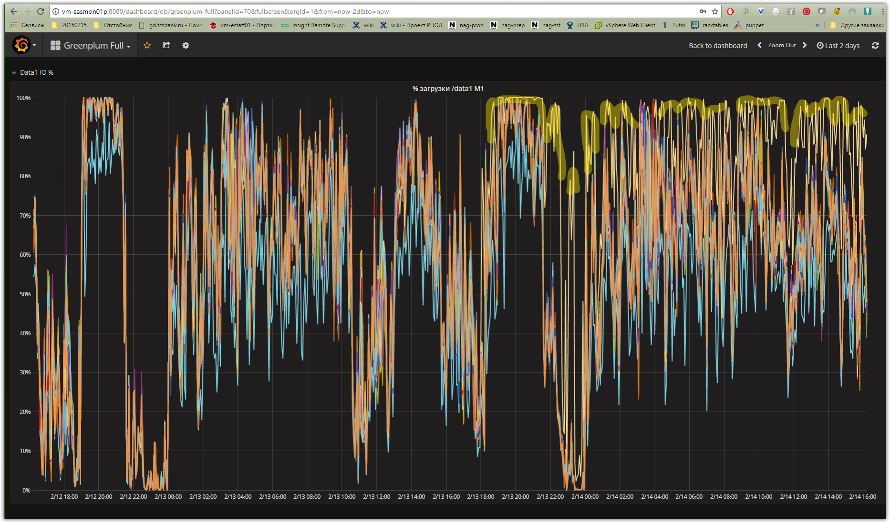
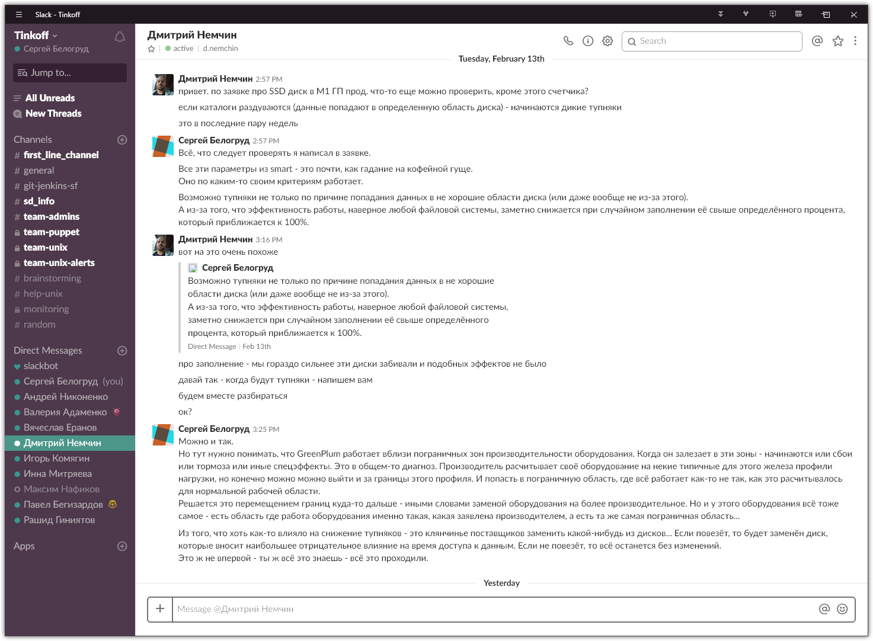
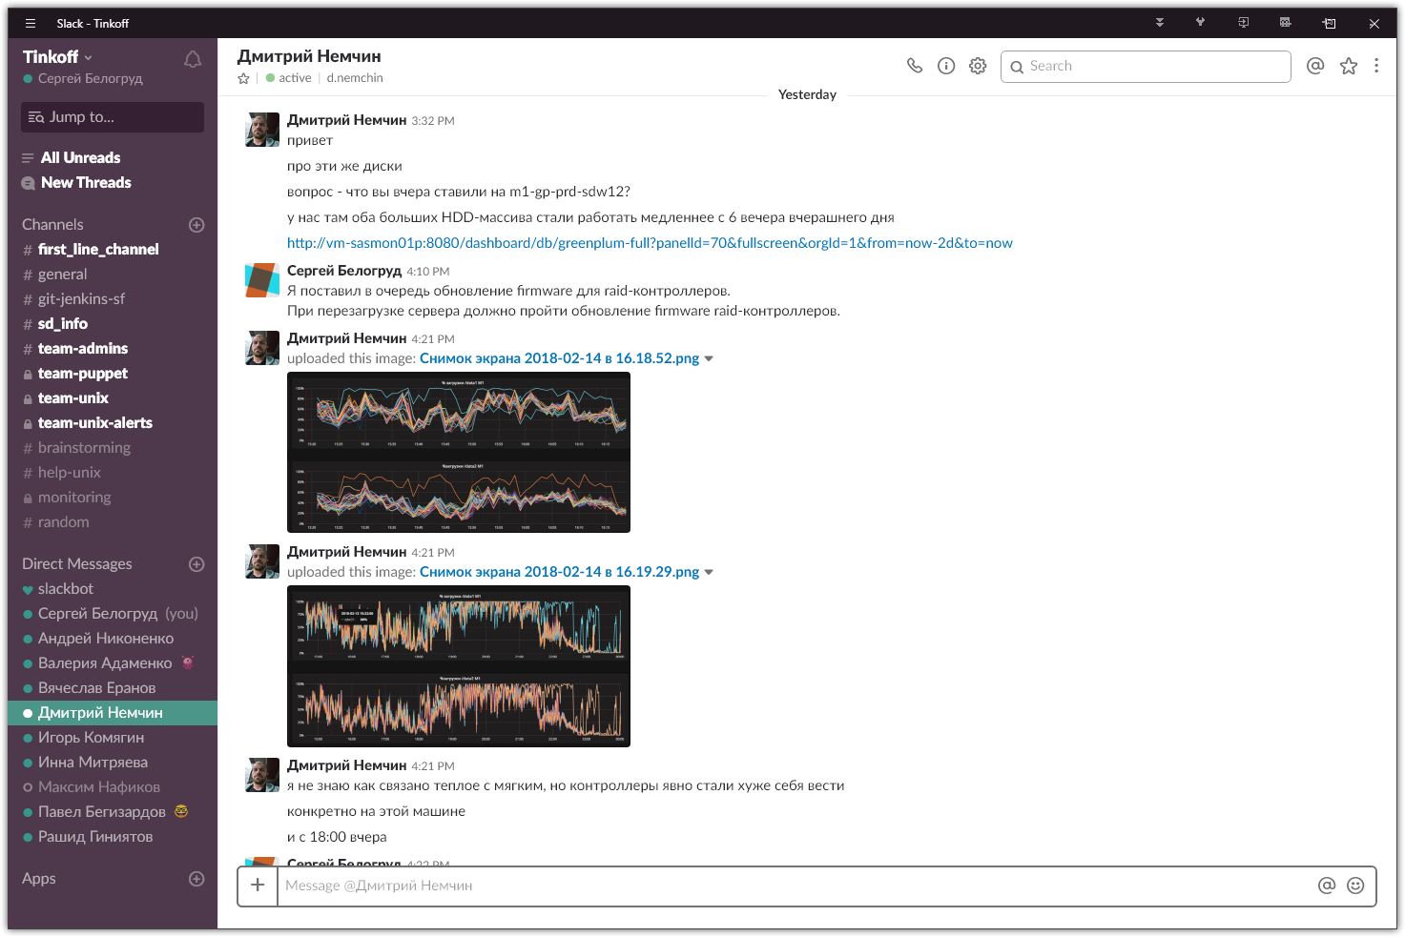
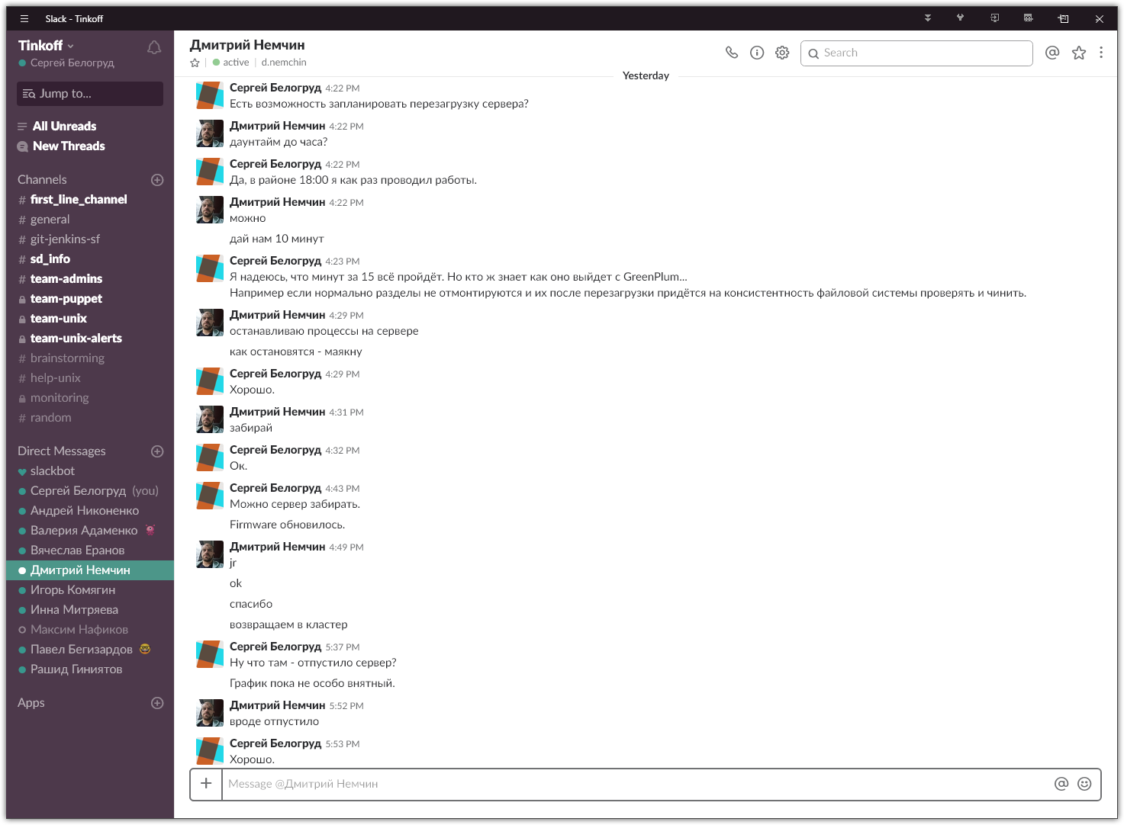

[root@m1-2-gp-prd-sdw12 ~]# dsu
DELL EMC System Update 1.5.2
Copyright (C) 2014 DELL EMC Proprietary.
Verifying catalog installation ...
Installing catalog from repository ...
Fetching dsucatalog ...
Reading the catalog ...
Fetching invcol_NJ94T_LN64_17_12_200_139_A00 ...
Verifying inventory collector installation ...
Getting System Inventory ...
Determining Applicable Updates ...

|--------DELL EMC System Update-----------|
[ ] represents 'not selected'
[*] represents 'selected'
[-] represents 'Component already at repository version (can be selected only if -e option is used)'
Choose: q - Quit without update, c to Commit, <number> - To Select/Deselect, a - Select All, n - Select None

[ ]1 13G Backplane Expander FW
Current Version : 3.03 Upgrade to : 3.35, Criticality : Urgent

[ ]2 BIOS
Current Version : 2.4.3 Upgrade to : 2.6.0, Criticality : Recommended

[ ]3 BCM57800 1-Gigabit Ethernet rev 10 (em4)
Current Version : 08.07.26 Upgrade to : 14.02.12, Criticality : Recommended

[ ]4 BCM57800 1-Gigabit Ethernet rev 10 (em3)
Current Version : 08.07.26 Upgrade to : 14.02.12, Criticality : Recommended

[ ]5 BCM57800 10-Gigabit Ethernet rev 10 (em2)
Current Version : 08.07.26 Upgrade to : 14.02.12, Criticality : Recommended

[ ]6 BCM57800 10-Gigabit Ethernet rev 10 (em1)
Current Version : 08.07.26 Upgrade to : 14.02.12, Criticality : Recommended

[ ]7 13G SEP Firmware, BayID: 1
Current Version : 0.00 Upgrade to : 2.25, Criticality : Optional

[-]8 Firmware for - Disk 0 in Backplane 1 of PERC H730P Mini Controller 0
Current Version : DM06 same as : DM06, Criticality : Recommended

[-]9 Dell 32 Bit uEFI Diagnostics, version 4239, 4239A36, 4239.44
Current Version : 4239A36 same as : 4239A36, Criticality : Optional

[ ]10 PERC H730P Adapter Controller 1 Firmware
Current Version : 25.5.2.0001 Upgrade to : 25.5.4.0006, Criticality : Urgent

[ ]11 PERC H730P Mini Controller 0 Firmware
Current Version : 25.4.0.0015 Upgrade to : 25.5.4.0006, Criticality : Urgent

[ ]12 iDRAC
Current Version : 2.41.40.40 Upgrade to : 2.50.50.50, Criticality : Recommended

[-]13 OS COLLECTOR 2.1, A00
Current Version : 2.1 same as : 2.1, Criticality : Recommended

Enter your choice : 10

|--------DELL EMC System Update-----------|
[ ] represents 'not selected'
[*] represents 'selected'
[-] represents 'Component already at repository version (can be selected only if -e option is used)'
Choose: q - Quit without update, c to Commit, <number> - To Select/Deselect, a - Select All, n - Select None

[ ]1 13G Backplane Expander FW
Current Version : 3.03 Upgrade to : 3.35, Criticality : Urgent

[ ]2 BIOS
Current Version : 2.4.3 Upgrade to : 2.6.0, Criticality : Recommended

[ ]3 BCM57800 1-Gigabit Ethernet rev 10 (em4)
Current Version : 08.07.26 Upgrade to : 14.02.12, Criticality : Recommended

[ ]4 BCM57800 1-Gigabit Ethernet rev 10 (em3)
Current Version : 08.07.26 Upgrade to : 14.02.12, Criticality : Recommended

[ ]5 BCM57800 10-Gigabit Ethernet rev 10 (em2)
Current Version : 08.07.26 Upgrade to : 14.02.12, Criticality : Recommended

[ ]6 BCM57800 10-Gigabit Ethernet rev 10 (em1)
Current Version : 08.07.26 Upgrade to : 14.02.12, Criticality : Recommended

[ ]7 13G SEP Firmware, BayID: 1
Current Version : 0.00 Upgrade to : 2.25, Criticality : Optional

[-]8 Firmware for - Disk 0 in Backplane 1 of PERC H730P Mini Controller 0
Current Version : DM06 same as : DM06, Criticality : Recommended

[-]9 Dell 32 Bit uEFI Diagnostics, version 4239, 4239A36, 4239.44
Current Version : 4239A36 same as : 4239A36, Criticality : Optional

[*]10 PERC H730P Adapter Controller 1 Firmware
Current Version : 25.5.2.0001 Upgrade to : 25.5.4.0006, Criticality : Urgent

[*]11 PERC H730P Mini Controller 0 Firmware
Current Version : 25.4.0.0015 Upgrade to : 25.5.4.0006, Criticality : Urgent

[ ]12 iDRAC
Current Version : 2.41.40.40 Upgrade to : 2.50.50.50, Criticality : Recommended

[-]13 OS COLLECTOR 2.1, A00
Current Version : 2.1 same as : 2.1, Criticality : Recommended

Enter your choice : c

Fetching SAS-RAID_Firmware_8WK8N_LN_25.5.4.0006_A12 ...
Installing SAS-RAID_Firmware_8WK8N_LN_25.5.4.0006_A12
Collecting inventory...
..............
Running validation...

PERC H730P Mini Controller 0

The version of this Update Package is newer than the currently installed version.
Software application name: PERC H730P Mini Controller 0 Firmware
Package version: 25.5.4.0006
Installed version: 25.4.0.0015

PERC H730P Adapter Controller 1

The version of this Update Package is newer than the currently installed version.
Software application name: PERC H730P Adapter Controller 1 Firmware
Package version: 25.5.4.0006
Installed version: 25.5.2.0001

Executing update...
WARNING: DO NOT STOP THIS PROCESS OR INSTALL OTHER PRODUCTS WHILE UPDATE IS IN PROGRESS.
THESE ACTIONS MAY CAUSE YOUR SYSTEM TO BECOME UNSTABLE!
.......................................................................................................................................
The system should be restarted for the update to take effect.
Please reboot the system for update(s) to take effect
Done! Please run 'dsu --inventory' to check the inventory
Exiting DSU!
[root@m1-2-gp-prd-sdw12 ~]# dsu --inventory
DELL EMC System Update 1.5.2
Copyright (C) 2014 DELL EMC Proprietary.
Verifying catalog installation ...
Installing catalog from repository ...
Fetching dsucatalog ...
Reading the catalog ...
Verifying inventory collector installation ...
Getting System Inventory ...

1. OpenManage Server Administrator ( Version : 8.5.0 )

2. BIOS ( Version : 2.4.3 )

3. Lifecycle Controller ( Version : 2.41.40.40 )

4. Dell 32 Bit uEFI Diagnostics, version 4239, 4239A36, 4239.44 ( Version : 4239A36 )

5. OS COLLECTOR 2.1, A00 ( Version : 2.1 )

6. System CPLD ( Version : 1.0.1 )

7. Power Supply ( Version : 00.16.4F )

8. Power Supply ( Version : 00.16.4F )

9. NVMePCISSD Model Number: HUSPR3216AHP301 ( Version : KMGNP120 )

10. Firmware for - Disk 0 in Backplane 1 of PERC H730P Mini Controller 0 ( Version : DM06 )

11. Firmware for - Disk 12 in Backplane 1 of PERC H730P Adapter Controller 1 ( Version : AM04 )

12. PERC H730P Mini Controller 0 Firmware ( Version : 25.4.0.0015 )

13. 13G Backplane Expander FW ( Version : 3.03 )

14. PERC H730P Adapter Controller 1 Firmware ( Version : 25.5.2.0001 )

15. iDRAC ( Version : 2.41.40.40 )

16. BCM57800 10-Gigabit Ethernet rev 10 (em1) ( Version : 08.07.26 )

17. BCM57800 10-Gigabit Ethernet rev 10 (em2) ( Version : 08.07.26 )

18. BCM57800 1-Gigabit Ethernet rev 10 (em3) ( Version : 08.07.26 )

19. BCM57800 1-Gigabit Ethernet rev 10 (em4) ( Version : 08.07.26 )

20. 13G SEP Firmware, BayID: 1 ( Version : 0.00 )

21. Inventory Collector ( Version : 2372.10488.el6 )

Exiting DSU!
[root@m1-2-gp-prd-sdw12 ~]#

#
# After server was rebooted, I’ve tested update firmware version to newer.
# The version was changed successfuly.
# By the way, exactly after reboot, when I’ve execute dsu utiltit, it exited soon with message, that it has not to get appropriate data. I’ve rerun it again after a minute and it start work properly. I thin there was not all appropriate data was received by inside Dell Live status controller, so it takes time to get it.
#
[root@m1-2-gp-prd-sdw12 ~]# dsu
DELL EMC System Update 1.5.2
Copyright (C) 2014 DELL EMC Proprietary.
Verifying catalog installation ...
Installing catalog from repository ...
Fetching dsucatalog ...
Reading the catalog ...
Verifying inventory collector installation ...
Getting System Inventory ...
Determining Applicable Updates ...

|--------DELL EMC System Update-----------|
[ ] represents 'not selected'
[*] represents 'selected'
[-] represents 'Component already at repository version (can be selected only if -e option is used)'
Choose: q - Quit without update, c to Commit, <number> - To Select/Deselect, a - Select All, n - Select None

[ ]1 13G Backplane Expander FW
Current Version : 3.03 Upgrade to : 3.35, Criticality : Urgent

[ ]2 BIOS
Current Version : 2.4.3 Upgrade to : 2.6.0, Criticality : Recommended

[ ]3 BCM57800 1-Gigabit Ethernet rev 10 (em4)
Current Version : 08.07.26 Upgrade to : 14.02.12, Criticality : Recommended

[ ]4 BCM57800 1-Gigabit Ethernet rev 10 (em3)
Current Version : 08.07.26 Upgrade to : 14.02.12, Criticality : Recommended

[ ]5 BCM57800 10-Gigabit Ethernet rev 10 (em2)
Current Version : 08.07.26 Upgrade to : 14.02.12, Criticality : Recommended

[ ]6 BCM57800 10-Gigabit Ethernet rev 10 (em1)
Current Version : 08.07.26 Upgrade to : 14.02.12, Criticality : Recommended

[-]7 PERC H730P Adapter Controller 1 Firmware
Current Version : 25.5.4.0006 same as : 25.5.4.0006, Criticality : Urgent

[-]8 PERC H730P Mini Controller 0 Firmware
Current Version : 25.5.4.0006 same as : 25.5.4.0006, Criticality : Urgent

[ ]9 iDRAC
Current Version : 2.41.40.40 Upgrade to : 2.50.50.50, Criticality : Recommended

[-]10 Firmware for - Disk 0 in Backplane 1 of PERC H730P Mini Controller 0
Current Version : DM06 same as : DM06, Criticality : Recommended

[-]11 Dell 32 Bit uEFI Diagnostics, version 4239, 4239A36, 4239.44
Current Version : 4239A36 same as : 4239A36, Criticality : Optional

[ ]12 13G SEP Firmware, BayID: 1
Current Version : 0.00 Upgrade to : 2.25, Criticality : Optional

[-]13 OS COLLECTOR 2.1, A00
Current Version : 2.1 same as : 2.1, Criticality : Recommended

Enter your choice : q
Exiting DSU!
[root@m1-2-gp-prd-sdw12 ~]#

# In addon, I’ve test info about version into iDRAC.
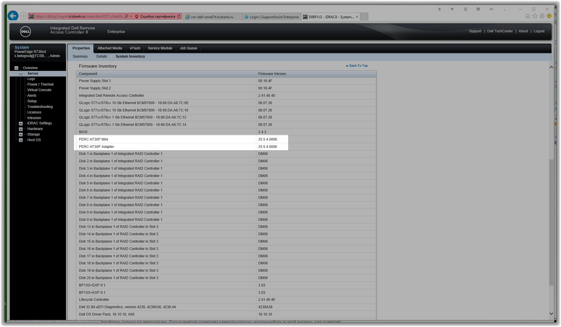

From: Chernyh Aleksandr Vladimirovich
Sent: Thursday, February 15, 2018 4:52 PM
To: unix-admins <unix-admins@tinkoff.ru>
Subject: nvmupdate

Коллеги, делюсь багом после использования dsu на ds-mvno-db01-prod:

Признаки: после dsu сервер долго отвечает, невозможно залогиниться и тд

Причины: nvmupdate вешает сервер (update firmware на Intel карточках)

Решение: убить nvmupdate, удалить бинарник /root/rhel7…

С уважением,

Александр Черных
Главный Системный Администратор

